Mentor Manual
2014

Table of Contents

Welcome Page 3

Agency Profile Page 4-5

Overview of the Homeless
History of the Homeless Page 6
The Homeless Today Page 7-8

Mentoring
Mentor Description Page 9
Rules of Communication Page 9
Mentor Topics of Discussion Page 10
Mentor Training and Development Page 11

Solicitation of Gifts and Gratuities Page 11

Mentor/ Mentee Life Cycle Page 12-13

Appendix
Stages of Psychosocial Development Page 14
Motor Development Page 15
Cognitive Milestones Page 16
Discipline Page 17
Parental Community Resources Page 18
Nutrition Page 19
Grocery Shopping Resource Page 20
Stress Page 21
Resume Building Page 22
Bill Assistance Page 23
Other Resources Page 24

Welcome

On behalf of the staff and Board of Trustees, we welcome you to Friends Association for Care and Protection of Children.

We view each volunteer as an important member of our team and wish you every success. This manual has been written to serve as the guide for the staff/volunteer relationship.

This handbook was developed to provide you with information regarding our expectations and to outline the policies, programs and benefits available to volunteers. It is not intended to be comprehensive or to address all the possible applications of, or exceptions to, the general policies and procedures described.

It is important that you familiarize yourself with the contents of the volunteer handbook as soon as possible as it may answer many of your questions about volunteering with Friends Association. If you have any questions concerning applicability of a policy or practice to you, you should address your specific questions to the Volunteer Coordinator.

We hope that your experience here will be challenging, enjoyable and rewarding. Again, welcome.

Sincerely,

Catherine Friedman John Spangler
Executive Director President, Board of Trustees

Welcome to Our Team!

Dear Volunteer:
Thank you for your interest in supporting the Friends Association We value your time and energy, as you are a vital member of our team. This manual should help you to become familiar with The Friends Association. Please know that we are always open to your suggestions, concerns and/or comments.

Here at The Friends Association, we are committed to working with each person on an individual basis. We want to build a mutually beneficial relationship in which you, our valued volunteer, use your strengths; passions and dedication to not only benefit Friends Association, but to positively enhance your own life. Volunteering at The Friends Association shows that you acknowledge the value of our mission. Thank you for your support and we look forward to working with you.

Robin Meixner
Volunteer Coordinator

Agency Profile

In 1814, Ann Yarnall organized a group of Quaker women to respond to the needs of orphaned “coloured children.” The organization was instituted in 1822 and chartered in 1829 as “The Association for Colored Orphans,” the name was later changed to “Friends Association for Care and Protection of Children.” Friends Association is the oldest continuously operating child welfare establishment in the Commonwealth of Pennsylvania.

Friends Association serves special needs and at risk children and their families. Another 100 children and 50 adult family members are served through our emergency shelter. Up to 15 families receive transitional housing and support services at a given time.

Our vision is to lead the community in eliminating homelessness for families with children so they will thrive in homes with a safe and stable environment.

We strive to increase the chances that children of all races and backgrounds reach their full potential. Our target population is families with children who are experiencing extreme economic deprivation and/or are socially fragile.

Friends Association’s Mission is to strengthen our community by providing programs and services that prevent homelessness and promote the independence of families with children.

Our program offerings include:

- An Emergency Family Shelter
- A Homeless Prevention Program

Need for Friends Programs

- Though Chester County is one of the wealthiest counties in Pennsylvania, the number of homeless or nearly homeless families continues to rise. This year over 28,000 people in the county are in poverty.

- The cost to rent a two-bedroom apartment ranges from $900-$1,200 in our community. According to the latest statistics provided by the Chester County Department of Community Development, the income needed to afford a two-bedroom apartment in Chester County is $40,200. Full time minimum wage is less than $15,000.

- The Public Health Management Corporation found in 2008 that 76.2% of Chester County's poor adults with household incomes below 100% of the poverty level are struggling to pay their housing costs.

- Many families we help have lost income or have had an unexpected expense (medical bills, high utility bills, or car repairs) or a job-hour reduction that puts them at risk of losing their housing. The gap between housing costs and income presents a major threat to the stability of the many low-income families Friends Association serves in our community. Families must choose between paying for housing and paying for basic needs.

- Chester County has a clear need for housing support for low-income families.

- The National Low Income Housing Coalition (2010) reported that there is not a single county in the nation in which a worker earning the federal minimum wage ($7.25 hour) can afford a one-bedroom apartment at Fair Market Rent.

- The Urban Institute (2008) found that only one in four households eligible for federal housing assistance receives assisted housing.

- The gap between the housing costs and income presents a major threat to the stability of low-income families.

- Friends Association is only one of three general family shelters in Chester County that serves women and their children. Of these three shelters, including ours, only 16 families can be housed at any given time.

- Based on the requests we receive for shelter, it is estimated that over 300 families, including women with children, experience homelessness each year in Chester County.

- The need for stable housing is especially critical for families with children. In the past year, over half of the women who worked with Friends Association were between 18 and 24 years old and the overwhelming majority of their children were under the age of five.

According to the National Center of Family Homelessness, homeless children go hungry twice as often as other children; homeless children get sick twice as often as other children; 50% of homeless children suffer from anxiety or clinical depression; and homeless children have four times the rate of developmental delays as other children. By providing stable housing, we help reduce or eliminate these problems.

Friends Association strengthens our community by providing programs and services that prevent homelessness and promote the independence of families with children. Friends Association has been serving homeless children since 1822 and is the oldest child welfare agency in Pennsylvania. The agency runs two programs: the Emergency Family Shelter and the Homeless Prevention Program.

Overview of the Homeless
This overview provides an explanation of a large group over a long period of time to facilitate an initial understanding, but also keep in mind individual differences.
History of the Homeless
This background information explains present day problems such as current causes of homelessness, defects in the system, and an understanding of those who struggle.
The “Worthy” and “Unworthy”
For the homeless in the 1640’s community compassion served as the only assistance allowing each community to support the “worthy” and kick out those considered “unworthy.” Without the help of government, many people without homes became wanders, moving from city to city looking for work and affordable housing. The worthy vs. unworthy mentality led to the “Greyhound Relief” governmental policy that provided bus tickets to the poor, encouraging movement in the late 20th Century. Neither situations were helpful to those considered “unworthy” because of lack of affordable housing in any of their new destinations.
Private and Public Assistance
Due to the large amount of people living on the streets, Almshouses opened in New York. The Almhouses had work requirements, setting the tone for current welfare policies. Without the help of federal government, private, local groups organized to fill the need. Many of these groups supplied housing, meals, and job training, but still kept the mentality of the “worthy” and “unworthy” poor.
The Great Depression
With a large amount of people out of work and living on the streets, the federal government stepped in with its first large scale response. It passed the Federal Emergency Relief Act, funding shelters, job training, meals, medical and dental care, and art programs.
Conclusion
Homelessness has always been a reality in American history, but at certain points in time homelessness becomes a larger concern. Society’s mindset of “worthy” and “unworthy” creates a stigmatization of the homeless. Another misconception is idea that the homeless are a homogenous group. A large amount of situations, such as class, race, gender and disabilities, put people in situations of homelessness, but in the end this problem comes down to the distribution of wealth and lack of affordable housing.

The Homeless Today
Currently a debate has taken over the issue of homelessness. The complex problem with a wide variety of issues baffles the nation. Homelessness cannot be eliminated with band-aid type actions such as soup kitchens and short-term homeless shelters. Instead outreach, prevention, supportive services and health care access has taken over. The American Recovery and Reinvestment Act of 2009 moves the nation towards these long-term solutions, with some states following in the federal government’s footsteps.
The Personal Side
As a mentor, history and large-scale issues help to set the correct mind frame, but a deeper, more personal level of understanding creates a more successful bond. The following poem expresses a point a view of the homeless.

My Name is Not “Those People”
By: Julia Dinsmore

My name is not "Those People".
I am a loving woman, a mother in pain,
Giving birth to the future, where my babies
Have the same chance to thrive as anyone.

My name is not "Inadequate".
I did not make my husband leave us -
He chose to, and chooses not to pay child support.
Truth is though; there isn’t a job base
For all fathers to support their families.
While society turns its head, my children pay the price.

My name is not "Problem and Case to Be Managed".
I am a capable human being and citizen, not just a client.
The social service system can never replace
the compassion and concern of loving grandparents, aunts,
uncles, fathers, cousins, community -
all the bonded people who need to be
But are not present to bring children forward to their potential.

My name is not "Lazy, Dependent Welfare Mother".
If the unwaged work of parenting,
homemaking and community building was factored
into the gross domestic product,
My work would have untold value. And why is it that mothers whose
Husbands support them to stay home and raise children
Are glorified? And why they don’t get called lazy or dependent?

My name is not "Ignorant, Dumb or Uneducated".
I got my PhD from the university of life, school of hard everything,
I live with an income of $621 with $169 in food stamps for three kids.
Rent is $585...That leaves $36 a month to live on.
I am such a genius at surviving,
I could balance the state budget in an hour.
Never mind that there's a lack of living-wage jobs.
Never mind that it's impossible to be the sole emotional, social,
Spiritual, and economic support to a family.
Never mind that parents are losing their children
to gangs, drugs, stealing, prostitution, the poverty industry,
social workers, kidnapping, the streets, the predator.
Forget about putting money into schools...
just build more prisons!

My name is not "Lay Down and Die Quietly".
My love is powerful, and the urge to keep my children alive will never stop.
All children need homes and people who love them.
All children need safety
And the chance to be the people they were born to be.
The wind will stop before I allow my sons to become a statistic.
Before you give in to the urge to blame me,
the blames that lets us go blind and unknowing
into the isolation that disconnects
your humanity from mine,
Take another look. Don't go away.
For I am not the problem, but the solution.
And...my name is not "Those People".
Mentoring
Mentor Description
“Mentoring is to support and encourage people to manage their own learning in order that they may maximize their potential, develop their skills, improve their performance and become the person they want to be” – Eric Parsloe, The Oxford School of Coaching & Mentoring
The relationship between mentee and mentor facilitates trust and encouragement. The guidance of a mentor allows the mentee to grow and experience new things with the safety and guidance of someone he or she trusts. A mentor is a friend, a role model and an advocate who listens and enables possibilities. A mentor should never be a counselor, a parent, a disciplinarian, source of income, or a protector.
http://www.mentorset.org.uk/pages/mentoring.htm
Duties of a Friends Association Mentor
- Visit the family frequently
- Inform the professional staff
- Keep records
- Maintain confidentiality
- Promote public relations in the community

Rules of Communication
- Make communication positive
- Be clear and specific
- Recognize that each individual has a different perspective
- Be open and honest about your feelings
- Accept his or her feelings and try to understand them
- Be supportive and accepting
- Do not preach or lecture
- Learn to listen
- Maintain eye contact
- Allow time for him or her to talk without interruption
- Show interest in what he or she says
- Get feedback to ensure understanding
- Listen for a feeling tone as well as for words
- Ask questions when you do not understand
- Set examples rather than give advice

Mentor Topics of Discussion
Parenting

- Understanding milestones (Appendix 1., 2., 3.)
- Enforcing discipline (Appendix 4.)
- De-Stressing
- Using community resources (Appendix 5.)
- Dealing with feelings
- Communicating
- Ending judgment
- Strengthening parent/ child relationship
- Dealing with school and homework

Household

- Setting up a chore chart
- Planning meals (Appendix 6.)
- Keeping a shopping list
- Managing mail
- Doing Laundry
- Staying organized
- Establishing a routine
- Establishing priorities
Personal Care
- Eating healthy (Appendix 7.)
- Establishing bedtimes
- Addressing illness
- Exercising
- Coping with stress (Appendix 8.)
- Incorporating hygiene
- Asking for help
Work /Career
  - Creating a resume (Appendix 9.)
  - Dressing appropriately
  - Working hard
  - Interviewing
  - Being confident

Financial
- Budgeting
- Setting financial goals
- Building savings
- Managing credit
- Organizing finances
- Paying bills (Appendix 10)

Mentor Training and Development

Orientation
All volunteers will receive a general orientation to introduce the volunteer to the nature and purpose of The Friends Association. This includes the history of the organization, roles of volunteers, benefits of volunteering, structure of the organization, key volunteer leaders, and resources.

During an orientation period, volunteers of the organization are apprised verbally and in writing of the code of ethics that Friends Association follows. Volunteers receive orientation prior to beginning their duties.

Training
Volunteers will receive position-specific training to provide them with the information and skills necessary to perform their volunteer assignment. The timing and methods for delivery will be appropriate to the complexity and demands of the position and the capabilities of the volunteer.

Solicitation of Gifts and Gratuities

Friends Association for Care and Protection of Children prohibits the solicitation and acceptance of gifts or gratuities by volunteers for their personal benefit in excess of minimal value.

Any volunteer found to violate this policy will be subject to disciplinary action up to and including discharge. Any act of fraud committed in solicitation or acceptance of a gift or gratuity will be reported to the proper authorities.

Mentor/ Mentee Life Cycle
Phase One: The Meeting and the First Months
The beginning of the mentor/ mentee relationship is a time to break through the initial awkwardness and get to know each other. To start the relationship off right, the mentor and mentee should create standards for this new relationship that stay consistent throughout this time together. These standards include meeting times and places, length of regular meetings, mutually enjoyable activities, and convenient ways of contact.
Possible Problems
- Mentor Decision Maker
The mentor should not always have a position of control. Discussing plans and other decisions should end in compromise of what both parties want. This develops respect between the mentor and mentee.

- Missed Meetings
To develop trust, respect each other’s time. The growth of the bond takes time, and without a scheduled routine, it cannot grow. If a cancelation is necessary contact the mentee in advance.

- Closed Off Mentee
During this period of uncertainty a mentee may express guarded or uncomfortable feelings. Be patient and do not become frustrated. To encourage discussion, frame questions that require longer answers. For example, ask “Why do you like baseball?” Follow up with more questions and find mutually enjoyable activities.

- High Expectations
The mentee and mentor may both come into the relationship hoping for initial success, but positive outcomes occur over time. During this phase the bond must build to allow for later successes. Keep the conversation light, and show appreciation for whom he or she is.
Phase Two: Building
At this time the mentor and mentee build on their initial relationship. Focus on deepening the friendship and sharing experiences. As the relationship gets deeper, the mentor will begin to understand the mentee more. Use this new trust to set goals and find ways to achieve them.
Possible Problems
- Dependent Mentee
The mentee may misunderstand the relationship and pass boundaries through excessive contact or invitations to inappropriate events. If this occurs, reinforce initial boundaries set in the first phase. Communicate concerns through ”I” to express feelings without blame, and listen to the mentee’s feelings.
- Need to Fix Problems
While the mentee goes through hard times, it may seem like a mentor’s responsibility to fix these problems. Remember that a mentor is not a social worker, and fixing problems is not a mentor’s job. If problems do arise, alert the program coordinator.

- Feeling Underappreciated
Devoting time to mentoring is rewarding, but sometimes a mentor feels unneeded or underappreciated. Keep in mind that a mentee may not express the thanks he or she feels to a mentor, and a mentor should not expect thanks. Instead understand the importance of a mentor’s role. If thanks are wanted, try setting an example by thanking the mentee.

Phase Three: Testing

At this point a mentee may test the relationship. He or she may cancel appointments at the last minute or act differently.

Possible Problems

- Frustration
While the mentee tests the relationship, a mentor may become frustrated. The mentor should understand that it is not personal. To ease the frustration, keep conversing. When the mentor proves support, the mentee will feel more comfortable in the relationship.

Ending the Relationship

The end of the mentor/ mentee relationship entails an understanding that the relationship is no longer beneficial. A mentor should explain the situation to the mentee to ensure a healthy parting. Whether the relationship ends due to the natural progress of the bond, a time constraint, or an ill fitting match, both parties deserve to find a more constructive situation.

Appendix 1.

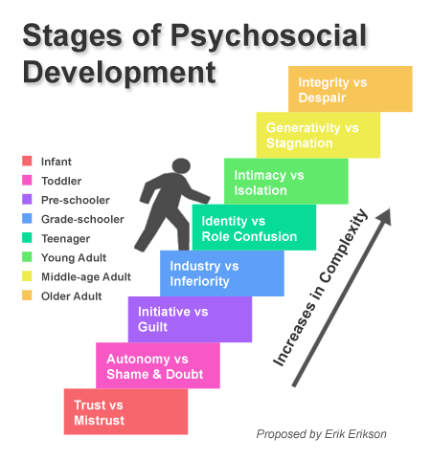
http://zanl13.wordpress.com/about/

Appendix 2.
http://thescienceofphysicalrehabilitation.blogspot.com/2011/06/trainers-corner-back-to-basics.html

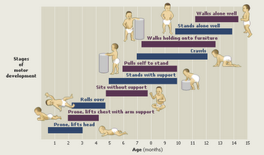

Appendix 3.

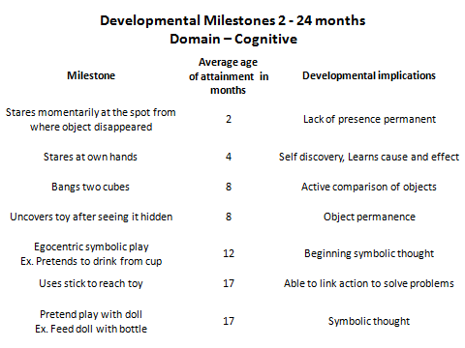
http://www.childhealth-explanation.com/milestones.html

Appendix 4.
Discipline

Positive Discipline

- Be proactive
- Promote positive behavior
- Encourage responsibility
- Respond appropriately to unacceptable behavior
- Protect self-esteem of child
- Strengthen parent/child relationship
- Facilitates development

Techniques

- Model appropriate behavior
- Encourage positive behavior
- Give attention to good behavior
- Create and maintain limits and rules
- Utilize time-outs to allow child to calm down
- Express emotions with “I”

Appendix 5.

Parental Community Resources

Big Brothers Big Sisters of America
450 E. John Carpenter Freeway, Suite 100
Irving, TX 75062
General Inquiries: (469) 351-3100
Fax: (972) 717-6507
General Inquiries: info@bbbs.org
Donations: donations@bbbs.org
Media Relations: media@bbbs.org
Alumni: alumni@bbbs.org

American Camp Association
5000 State Road 67 North
Martinsville, IN 46151-7902
Phone: 800-428-2267
Phone: 765-342-8456
Fax: 765-342-2065
Web: www.ACAcamps.org

Childcare Information Services
1800 870 2323

For more community programs visit http://www.referweb.net/chesco/

Appendix 6.

http://www.choosemyplate.gov/budget/index.html

Save More at the Store
The smartest shoppers know that saving money is more than luck. When shopping for groceries, it’s about having a game plan and making smart decisions about what to put in your cart.
Stretch your dollar with these helpful tips:
- Eat before you shop. Grocery shopping hungry can lead to impulse buying and unhealthy food choices.
- Read the sales flyer. Sales flyers are usually released mid-week and can be found at the store’s entrance, in the newspaper, or on their website.
- Use coupons – but only for items that you know you’ll use. If you don’t need an item right away, save the coupon and see if it goes on sale.
- Look up and down for savings. Stores often stock the priciest items at eye level. You can save big by looking at the upper and lower shelves too.
- Check for store brands. Most stores offer their own brand of products that often cost less than name brands.
- Grab from the back. Stores typically stock shelves from back to front, placing the newest items behind the older ones. Reach in the back for the freshest items especially in the produce, dairy, and meat aisles.
- Ask for a rain check. If a sale item has run out, ask the store for a rain check. This allows you to pay the sale price after the item is restocked.
- Join your store’s loyalty program. Most stores offer a free loyalty program. Get special offers and discounts that non-members do not.
Check out these other helpful resources for more information:
USDA’s Nutrition Assistance Programs: Eat Right When Money’s Tight
Eating on a Budget – The 3 P’s
Eating Better on a Budget – 10 Tips
Saving Money with Coupons

Appendix 7.
http://www.choosemyplate.gov/food-groups/downloads/TenTips/DGTipsheet12BeaHealthyRoleModel-BlkAndWht.pdf
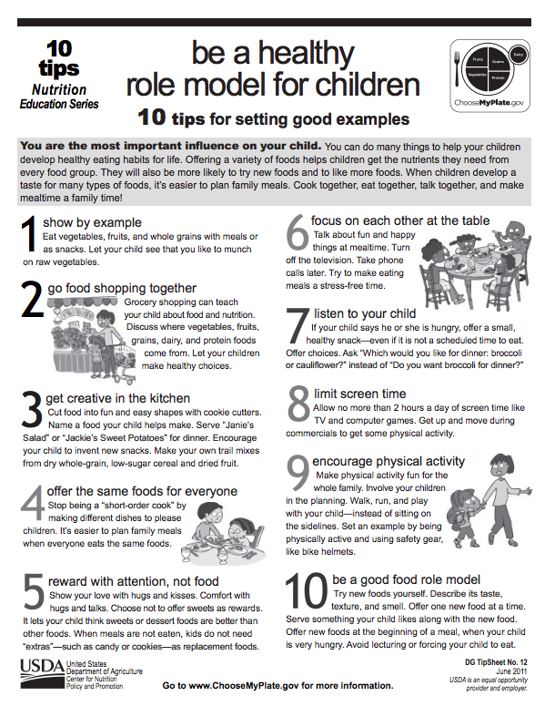

Appendix 8.

Stress

Stress Identifiers:

- Overwhelming feelings
- Depression
- Anxiety
- Headaches
- Nausea
- Extreme tiredness

Dealing with Stress

When mentees show signs of stress, help them admit their feelings. Ask questions and listen to what he or she has to say. A mentee may be overwhelmed and have no techniques to deal with these feelings. Mentors should model stress relieving behaviors they use to in their daily lives and brainstorm activities that benefits the mentor and mentee in times of stress.

Appendix 9.

Resume Building

PA HOME OF THE SPARROW
969 E. Swedesford Road
Exton, PA 19341
(610) 647-4940 Homelessness Prevention
(610) 647-5256 Shared Housing
(610) 240-7268 FAX
(610) 436-9067 Transitional Housing, Supportive Housing, & Graduate Outreach
http://homeofthesparrow.org/
info@homeofthesparrow.org

Appendix 10.

Bill Assistance

OXFORD AREA NEIGHBORHOOD SERVICES CENTER
35 North Third Street
Oxford, PA 19363
(610) 932-8270 Fax
(610) 869-8557 Service/Intake
(610) 932-8557 Service/Intake
http://oxfordnsc.org/
nsc35@zoominternet.net
SERVICES: Basic Needs Assistance

HOUSING PARTNERSHIP OF CHESTER COUNTY
41 West Lancaster Avenue
Downingtown, PA 19335
(610) 518-3221 FAX
(610) 518-1522 Service/Intake
http://housingpartnershipcc.com/
hpcc.info@verizon.net
SERVICES: Foreclosure Prevention and Credit Counseling

OPEN HEARTH, INC.
101 North Main Street Suite A-1
Spring City, PA 19475
(610) 792-9282 Service/Intake
http://www.openhearthinc.org/
openhearthinc@verizon.net
SERVICES: Family Savings Partner Program
Financial Insight & Resource Management (FIRM)

Appendix 11.
Other Resources

Veterans Affairs
610-344-6375
601 Westtown Rd. Suite 385

