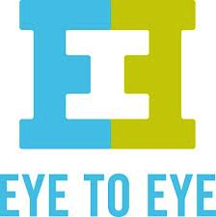

Become A Part of Our Community,
Because Everyone Thinks Differently!

What are learning disabilities and ADHD?

Learning disabilities cause trouble storing, processing, or producing new information despite average or above average intelligence. Attention Deficit Hyperactive Disorder is not considered a learning disability, but it interferes with learning in a similar way.

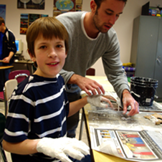
Why should I support the learning disabled?

Students with learning disabilities may consider themselves stupid due to the stigma of their diagnosis. In reality, all of the learning disabled have the potential to succeed, but they may need extra help in the classroom. With understanding and support from their community, we can show them it is okay to be different, because everyone thinks differently. When we look past our differences and focus on our similarities great things can be accomplished.

How Does Eye to Eye Help Your Community?

Eye to Eye wants to empower the 20% of Americans with learning disabilities and ADHD to make our communities, and eventually our a world, an accepting place. While making art projects academic empowerment, self-advocacy, hope for the future, and self-esteem develops through open discussions about shared struggles. Mentors also learn how to become better advocates, and feel a sense of support within their community. Through the program mentors and mentees become better citizens. When supporting the learning disabled community, your community gains great thinkers, problem solvers, and happier citizens.
“If we had chapters of Eye to Eye in every school we wouldn’t need as much remediation and special education”

-Natalie Tamburello, Chapter Coordinator
“Its given him more confidence to be who he is”

-Laura Maloney, Parent of Mentee

